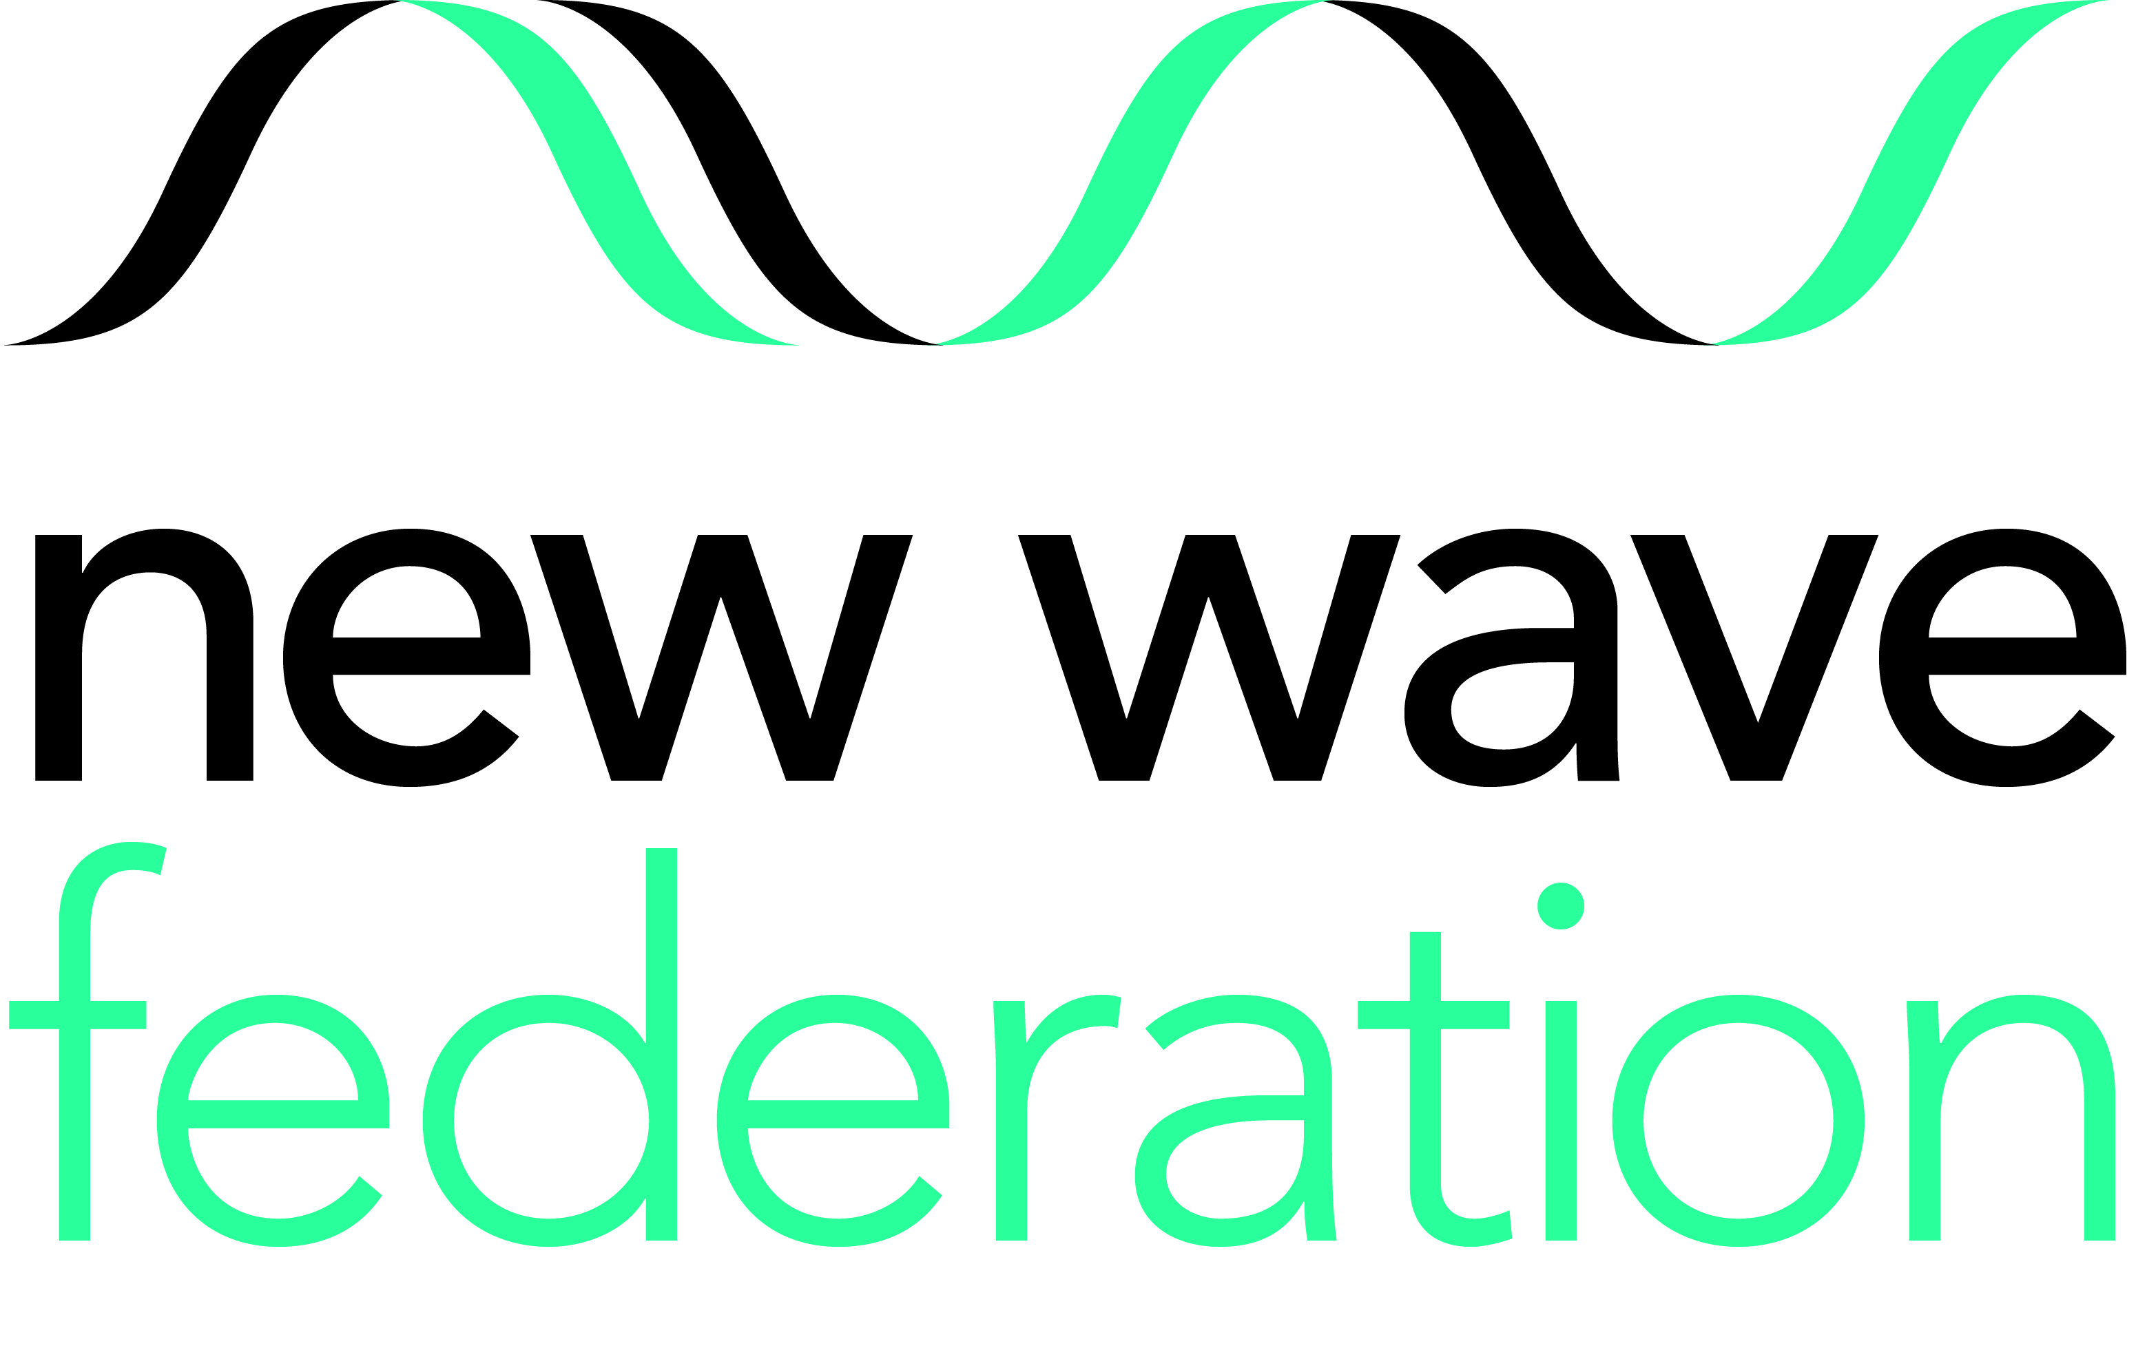

Teaching Assistant
from September 2019 – July 2020 (Fixed-Term)
Scale 4 (point 7 – 10) £23,628.00 - £24,927.00 pro-rata term time only
30 hours a week 8.45am – 3.45pm

The New Wave Federation consists of 3 high performing and innovative primary schools in Hackney, London. In all our schools we have a passion for high standards and want all our children to achieve their potential and be inspired to go beyond that. We aim to provide the best possible primary education in a stimulating and creative environment. Vacancies are available across all three school sites.

We are looking to appoint teaching assistants to work in classrooms as a general support and 1 to 1 support for children with special educational needs.

The role requires someone who is passionate about children’s learning and who has a rich knowledge and understanding of how learners learn. Previous experience of working as a Teaching Assistant is essential. The right person will be someone who is up to date with 21st century education, who can use new technologies and who is creative and resourceful. Our parents and carers want the very best education for their children and so do we.
Your communication skills will enable you to build a friendly and professional relationship with staff, pupils and parents. Our schools are vibrant, diverse and inclusive. There are challenges but also great rewards in the work here. If you are an effective communicator, have vision, energy and believe that every child can and will succeed, we would like to meet you.
HOW TO APPLY: Please download the application pack from the Hackney Learning Trust website, alternatively email: llangley@newwavefederation.co.uk or phone 020 8802 4051 for a pack to be sent out.
Closing date for applications: 12pm Friday 14th June 2019
Interview date: w/c Monday 24th June 2019

GRAZEBROOK PRIMARY SCHOOL WOODBERRY DOWN COMMUNITY PRIMARY SCHOOL
Lordship Road Woodberry Grove
London N16 0QP London N4 1SY
0208 802 4051 020 8800 5758
www.grazebrook.hackney.sch.uk www.woodberrydown.hackney.sch.uk

SHACKLEWELL PRIMARY SCHOOL
Shacklewell Row
London E8 2EA
Phone: 0207 254 1415
www.shacklewell.hackney.sch.uk

The New Wave Federation of schools is committed to safeguarding and promoting the welfare of children and young people. All posts are subject to an enhanced DBS check. We welcome applications from all sections of the community, regardless of gender, race, religion, disability, sexual orientation or age. This post is likely to come under the requirements of the Disqualification under the Childcare Act 2006 and the successful applicant will be required to complete a self- declaration form to establish whether they are disqualified under these regulations.

