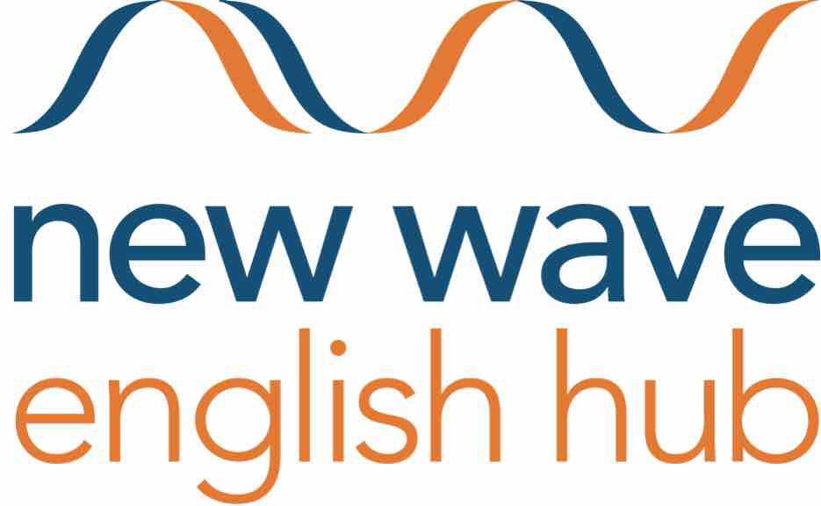
English Hubs English Hub

New Wave Federation & English Hub
@ Grazebrook School

Development & Marketing Officer
From September 2019 – July 2020 (Fixed Term)
Scale 6 (point 18-20) £28,752.00 - £29,796.00 pro rata term time only
4 days a week Monday – Thursday (8.30am – 3.00pm)

The New Wave Federation consists of 3 high performing and innovative primary schools in Hackney, London. In all our schools we have a passion for high standards and this has been recognised by the Department for Education in appointing Grazebrook Primary school as an English Hub in September 2018. The hub supports schools countrywide to deliver excellent early language and phonics teaching in Reception and Key Stage 1. We also deliver high quality teacher training through our Teaching School. Our Hub and Teaching School department is flourishing and we would like you to join us.

We are seeking a highly motivated and passionate candidate who can demonstrate they have:

- A deep understanding of successful development and marketing principles
- Excellent administrative and organisational practices
- Outstanding spoken and written communication
- Experience in business organisations and able to use their own initiative
- Possess excellent communication and interpersonal skills
- Inspirational and dedicated to making a difference
- Are good team players

We can offer you schools which are;
- Well-resourced, have friendly, dedicated staff with high expectations
- Have good opportunities for professional development
- Are outstanding and hold Apple Distinguished Schools Status

This role is based at Grazebrook Primary School however you may be requested to work across the federation if the need arises. In all our schools we have a passion for high standards and want all our children to achieve their potential and be inspired to go beyond that. If you think you can help us on our quest for excellence then please come and join our happy and vibrant teams. The right person will be someone who is up to date with 21st century education, who can use new technologies and who is creative and resourceful.

Application packs are available from llangley@newwavefederation.co.uk and we warmly welcome and encourage school visits. Please call us on 020 8802 4051.
Closing date for applications: Friday 14th June 2019 12pm
Interviews w/c Monday 24th June 2019

GRAZEBROOK PRIMARY SCHOOL WOODBERRY DOWN COMMUNITY PRIMARY SCHOOL
Lordship Road Woodberry Grove
London N16 0QP London N4 1SY
0208 802 4051 020 8800 5758
www.grazebrook.hackney.sch.uk www.woodberrydown.hackney.sch.uk

SHACKLEWELL PRIMARY SCHOOL
Shacklewell Row
London E8 2EA
Phone: 0207 254 1415
www.shacklewell.hackney.sch.uk
The New Wave Federation of schools is committed to safeguarding and promoting the welfare of children and young people. All posts are subject to an enhanced DBS check. We welcome applications from all sections of the community, regardless of gender, race, religion, disability, sexual orientation or age.

