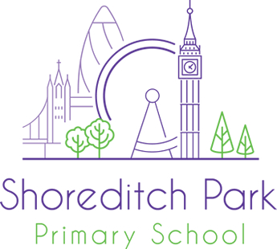
KS2 Year 4 Teacher, Hackney

Employer | Shoreditch Park Primary School
Location | Hackney
Salary | MPS with TLR for exceptional candidate
Contract type | Full Time
Contract term | Permanent
Job dates
Posted | 4th June 2019
Closing date | 14th June 2019
Job starts | 2nd September 2019

Welcome to Shoreditch Park Primary School
Are you a passionate practitioner with a genuine commitment to inclusive and innovative education to raise standards for all? If so we’d love to hear from you.
Shoreditch Park is a thriving and high performing school in Hackney. We are looking to recruit a committed teacher to join our experienced, forward looking and supportive team. You will be joining us on an exciting part of our journey to excellence. We have achieved many successes; we are a recognised Visible Learning Intervention School (John Hattie), Rights Respecting School and a Centre of Excellence for Inclusion (IQM). At the heart of our achievement is the belief that every child can flourish in a calm, structured and stimulating environment. As a result pupil behaviour is exemplary and outcomes are high. Teachers are free to teach and experience real success in the classroom.
We have wonderful children and dedicated staff that go that extra mile every day.
We are looking for a KS2 Year 4 Teacher (NQT’s and experience teachers welcome to apply) who can:
· Demonstrates a clear understanding of what constitutes outstanding teaching and learning
· Shows commitment to ensuring equality of opportunity for all learners
· Is reflective, open to feedback and driven to be outstanding
· Is a dedicated team player
· Demonstrate optimism about children and expect the highest possible standards.

We offer:
· A passionate, driven and successful school where you will feel well supported in your role
· A robust induction process
· A school that is committed to ensuring that every child succeeds
· Individualised professional development and career enhancement opportunities
· A comprehensive Wellbeing Policy which includes benefits such as free membership to employee assistance program
· The support of an experienced Senior Leadership Team.
Please visit our website, www.shoreditchpark.hackney.sch.uk, for further information about Shoreditch Park Primary School and to download an application pack.
Visits to the school are strongly recommended.
Contact Nicola Cavanna at vacancies@shoreditchpark.hackney.sch.uk to arrange a visit.

Closing date for applications: 9am 14th June 2019

Interviews: Week Commencing 17th June 2019 (We reserve the right to interview exceptional candidates prior to the closing date and references will be requested for shortlisted candidates).
Shoreditch Park Primary School is committed to safeguarding all children. Successful candidates will require a DBS clearance and suitable references before commencing employment. We are committed to diversity, equality and inclusion and welcome applications from all section of the community, regardless of gender, race, religion, disability, sexual orientation or age.

